**WEB DEVELOPMENT INTERNSHIP PROJECT 1**

**Name**: Pratik Pawar

**Project Title:** Personal Bucket List

**Internship Name:** Web Development Internship

**Submission Date:** 25/01/2025

**Email:** pratikpawar7225@gmail.com

**Phone number:** 9552524565

**Table of Contents**

1. Introduction
2. Objective
3. Project Details
4. Features Implemented
5. Challenges and Learnings
6. Responsive Design and Testing
7. Code Snippets
8. Screenshots
9. Conclusion

**Introduction**

The "Personal Bucket List" project is a dynamic and visually appealing web development endeavor aimed at showcasing a user’s personal aspirations, goals, and dreams in a structured and interactive format. This project involves designing a responsive webpage that integrates styled lists, decorative icons, and modern visual design elements to enhance user engagement and experience. The primary objective is to develop a platform where users can organize their bucket list items, mark tasks as completed, and visually track their progress in an intuitive and aesthetically pleasing manner.

In the current era of technology, where internet usage spans across a multitude of devices, creating responsive web pages is more crucial than ever. Responsive design ensures that web content seamlessly adapts to various screen sizes and resolutions, providing an optimal user experience irrespective of the device being used. Whether accessed on a desktop, tablet, or smartphone, responsive web pages improve readability, usability, and accessibility. This not only enhances user satisfaction but also aligns with modern web standards, making responsive design a fundamental skill for web developers. Through this project, the importance of responsive web design is emphasized by implementing features that guarantee a consistent and user-friendly experience across all platforms.

**Objective**

The main goal of the "Personal Bucket List" project is to create a visually engaging and fully responsive webpage that allows users to organize and showcase their personal goals, dreams, and aspirations in an interactive and user-friendly manner. The project focuses on combining modern web design principles with practical functionality by implementing features such as styled lists with decorative icons, progress tracking for each item, and responsive layouts that adapt seamlessly to various screen sizes.

This project aims to enhance user engagement by employing clean typography, consistent color schemes, and animations while ensuring accessibility and usability on all devices. By achieving these objectives, the project serves as a practical exercise in mastering core web development skills, including HTML, CSS, and responsive design techniques, while cultivating an eye for layout and design aesthetics.

**Project Details**

The "Personal Bucket List" project is designed to provide an engaging platform for users to visually organize and track their aspirations. The webpage is structured to balance functionality with aesthetics, ensuring a seamless and appealing user experience across all devices. Below are the key components and details of the project:

**Structure of the Project**

1. **Header**
   * Contains the project title ("My Ultimate Bucket List") and a tagline to set the theme.
   * Positioned at the top of the page with prominent typography for instant recognition.
2. **Main Section**
   * Features a bucket list displayed as an unordered list.
   * Each list item includes:
     + Decorative icons indicating completion status (✔️ for completed, ❌ for not completed).
     + A text description of the goal.
     + A progress bar visualizing the completion percentage for each task.
3. **Footer**
   * Includes a scrolling animation with motivational text ("Designed for the adventurous soul 🚀").
   * Positioned at the bottom, providing a dynamic and polished finishing touch.

**Technologies Used**

* **HTML5**: Used for creating the semantic structure of the webpage, including headings, lists, and other content elements.
* **CSS3**: Employed to enhance the visual design with features such as:
  + Styled lists and progress bars.
  + Typography, spacing, and color schemes for a cohesive look.
  + Media queries for responsive design.
* **JavaScript (optional)**: Can be added for dynamic functionality, such as interactive user inputs or animations.

**Key Features**

1. **Styled Lists**
   * Unordered lists are used to display bucket list items.
   * Decorative icons (e.g., checkmarks, crosses) are added for a quick visual representation of completion status.
2. **Visual Design**
   * The design emphasizes readability and aesthetics with a clean layout.
   * Typography is carefully chosen for clarity and to convey the theme.
   * A cohesive color scheme is applied to maintain visual harmony.
3. **Responsive Design**
   * The webpage adapts to various screen sizes using CSS media queries, ensuring usability on desktops, tablets, and smartphones.
   * Flexbox and Grid layouts are utilized for precise alignment and spacing.

**Features Implemented**

The "Personal Bucket List" project incorporates a range of features designed to enhance functionality, visual appeal, and adaptability across various devices. Below is a detailed explanation of the key features implemented:

**1. Styled Lists**

* **Decorative Icons**:  
  Each bucket list item is accompanied by an icon that visually represents its completion status:
  + ✔️ (Check-mark) for tasks that are completed.
  + ❌ (Cross) for tasks that are not yet completed.  
    These icons provide immediate visual feedback and make the list more intuitive and engaging.
* **Progress Bars**:  
  Each item includes a progress bar that visually indicates how much of the task is completed (e.g., 100% for completed, partial progress for ongoing tasks). This adds an interactive and visually dynamic element to the list.

**2. Visual Design**

* **Typography**:  
  Carefully selected fonts are used to ensure readability and to complement the theme of aspiration and achievement.
  + Headers (e.g., "My Ultimate Bucket List") are styled with bold, large fonts to grab attention.
  + List items are styled with clean, modern fonts for clarity and readability.
* **Alignment**:
  + The layout uses **CSS Flexbox** and **Grid** to align elements precisely, ensuring a clean and balanced presentation.
  + Items within the list are spaced consistently, creating a visually pleasing hierarchy.
* **Color Scheme**:
  + A cohesive palette is applied, with soft tones for the background and vibrant colors for progress indicators, icons, and text highlights.
  + Hover effects add subtle animations, enhancing the interactive experience.

**3. Responsive Design**

* **Media Queries**:  
  The webpage is designed to adapt seamlessly to different screen sizes:
  + For **desktops**: The layout is spacious and utilizes the full width effectively.
  + For **tablets and mobile devices**: Media queries adjust font sizes, spacing, and layout to ensure readability and usability on smaller screens.
* **Scalable Components**:
  + The bucket list items stack vertically on smaller screens for easy navigation.
  + The progress bars and icons adjust their size dynamically to fit within the reduced space.

**Challenges and Learnings**

The "Personal Bucket List" project presented several challenges during its development, which served as valuable learning opportunities. Below is a summary of the challenges faced and the new concepts learned:

**Challenges Faced**

1. **Implementing Responsive Design**
   * Ensuring the layout and components adjusted seamlessly across various screen sizes was challenging.
   * Creating media queries for different breakpoints while maintaining a visually consistent design required multiple iterations and testing.
2. **Styling Progress Bars and Decorative Icons**
   * Designing progress bars that dynamically reflect task completion while maintaining visual harmony with the list items required precise use of CSS properties.
   * Positioning decorative icons alongside list items without affecting alignment was initially difficult, especially in responsive layouts.
3. **Footer Animation**
   * Creating a smooth scrolling animation for the footer text while ensuring it remained functional and visually appealing posed a challenge.
   * Synchronizing the animation speed and direction with the overall design required adjustments to CSS keyframes and testing on various devices.
4. **Typography and Color Scheme Selection**
   * Balancing readability and aesthetics with appropriate font styles and sizes was challenging, particularly for smaller screens.
   * Choosing a cohesive color palette that complemented the theme without overwhelming the user interface required careful consideration.

**New Concepts Learned**

1. **CSS Grid and Flexbox**
   * Mastered the use of **CSS Grid** for creating structured layouts and aligning elements efficiently.
   * Combined **Flexbox** with Grid to handle dynamic content alignment, especially for smaller screens.
2. **Media Queries for Responsiveness**
   * Learned how to use **CSS media queries** to adapt designs to different screen resolutions and orientations.
   * Explored techniques for resizing elements proportionally to maintain consistency across devices.
3. **CSS Animations**
   * Gained hands-on experience with **CSS keyframes** to implement smooth scrolling animations for the footer.
   * Learned how to fine-tune animation timing, delays, and easing functions to achieve desired effects.
4. **Progress Bar Styling**
   * Learned to design and animate progress bars using **CSS transitions**, adding dynamic feedback for task completion.
5. **Typography and Color Theory**
   * Explored the relationship between typography and user experience, learning how to enhance readability and thematic consistency.
   * Applied color theory to develop a palette that balanced contrast, vibrancy, and harmony.

**Code Snippets**

**1. Styled List**

This snippet demonstrates how the bucket list items were styled with decorative icons, progress bars, and dynamic classes for completed or not-completed tasks.

<ul class="bucket-list">

<!-- List Item 1 -->

<li>

<div class="item">

<span class="icon completed">✔️</span> <!-- Icon for completed task -->

<span class="text">Climb Mount Everest</span> <!-- Task description -->

</div>

<div class="progress-bar">

<div style="width: 100%;"></div> <!-- Full progress bar -->

</div>

</li>

<!-- List Item 2 -->

<li>

<div class="item">

<span class="icon not-completed">❌</span> <!-- Icon for not completed task -->

<span class="text">Own a Sports Car</span>

</div>

<div class="progress-bar">

<div style="width: 60%;"></div> <!-- Partial progress bar -->

</div>

</li>

</ul>

.bucket-list {

list-style: none;

padding: 0;

}

.item {

display: flex;

align-items: center;

margin-bottom: 10px;

}

.icon {

font-size: 1.5rem;

margin-right: 10px;

}

.progress-bar {

height: 10px;

background-color: #e0e0e0;

border-radius: 5px;

overflow: hidden;

margin-top: 5px;

}

.progress-bar div {

height: 100%;

background-color: #4caf50;

transition: width 0.3s ease;

}

**2. Media Queries for Responsiveness**

This snippet highlights the use of media queries to adapt the layout for different screen sizes.

/* Tablet View */

@media (max-width: 768px) {

header h1 {

font-size: 2rem; /* Adjust font size for smaller screens */

}

.bucket-list li {

flex-direction: column; /* Stack items vertically */

align-items: flex-start;

}

.icon {

margin-right: 5px; /* Reduce spacing for icons */

}

}

/* Mobile View */

@media (max-width: 480px) {

header h1 {

font-size: 1.8rem; /* Further reduce font size */

}

header p {

font-size: 1rem;

}

footer {

font-size: 0.9rem; /* Scale down footer text */

}

}

**3. Footer Animation**

The footer text scrolls from right to left, creating a dynamic and engaging effect.

<footer>

<div class="scrolling-text">

<p>Designed for the adventurous soul 🚀</p>

</div>

</footer>

footer {

background-color: #333;

color: white;

text-align: center;

padding: 10px 0;

position: fixed;

bottom: 0;

width: 100%;

overflow: hidden;

}

.scrolling-text {

white-space: nowrap;

display: inline-block;

animation: scroll-left 10s linear infinite; /* Scrolling animation */

}

@keyframes scroll-left {

0% {

transform: translateX(100%); /* Start from the right */

}

100% {

transform: translateX(-100%); /* End at the left */

}

}

**Screenshots.**

**Desktop View**

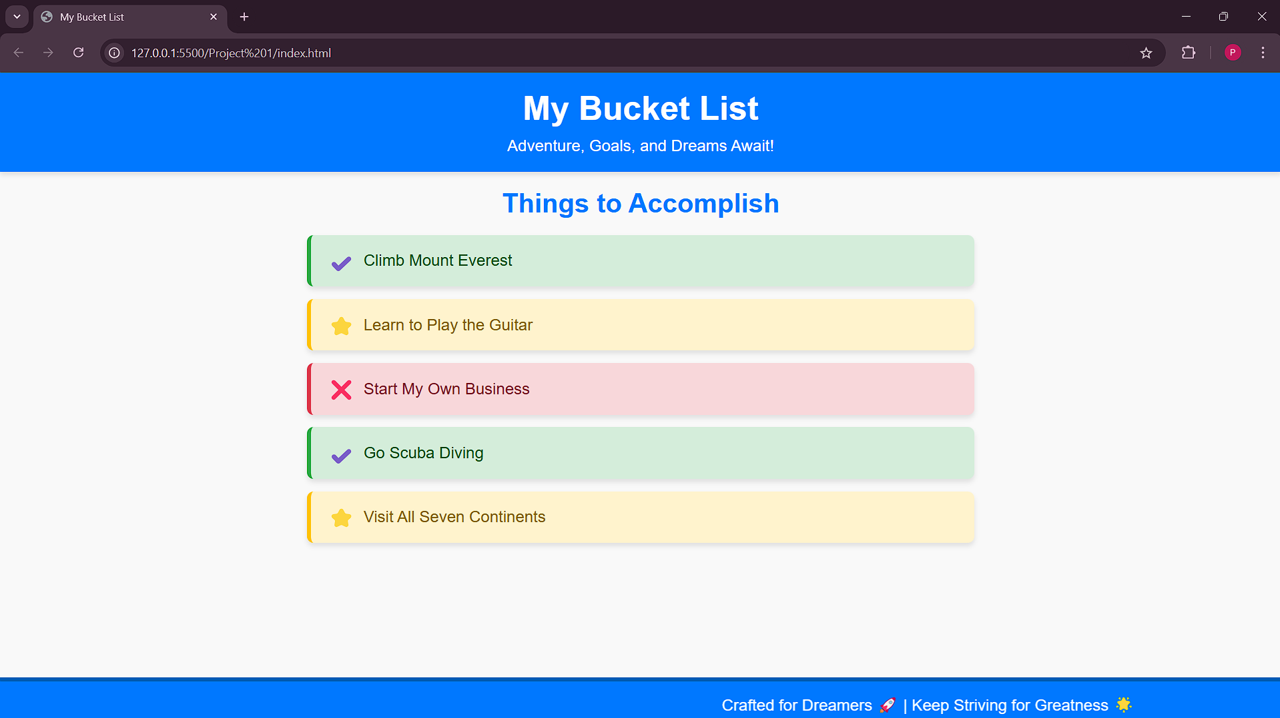

**Mobile View.**

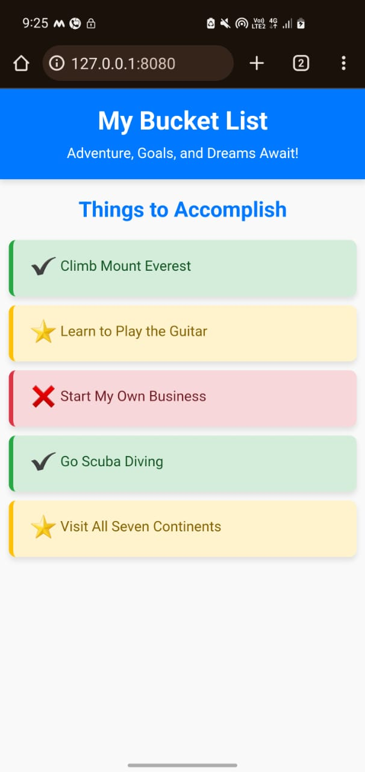

**Conclusion**

**Summary of the Project**

The "Personal Bucket List" project successfully achieved its primary objective of creating a visually engaging, interactive, and responsive webpage. Through the use of modern web development practices, including styled lists, progressive enhancements, and media queries, the project provided an elegant solution for presenting bucket list items. Features like decorative icons, progress bars, and a dynamically animated footer enhanced the user experience and added a professional touch to the webpage design.

**Value Added to My Skillset**

This project was an invaluable learning experience, significantly expanding my understanding of web development. Key takeaways include:

* **Advanced Styling Techniques**: Learned to implement visually appealing elements using CSS, such as progress bars, responsive layouts, and smooth animations.
* **Responsive Design**: Gained proficiency in using CSS media queries to create layouts adaptable to various devices and resolutions, ensuring optimal usability.
* **Dynamic Animations**: Explored the use of @keyframes to add engaging animations, such as the scrolling footer effect, enhancing the webpage’s interactivity.
* **Problem-Solving**: Overcame challenges in aligning elements, maintaining consistency across resolutions, and ensuring smooth performance on mobile and desktop devices.

This project served as a strong foundation for tackling more complex web development tasks, solidifying my skills in HTML5 and CSS3, and instilling confidence in my ability to design responsive and aesthetically pleasing web pages.